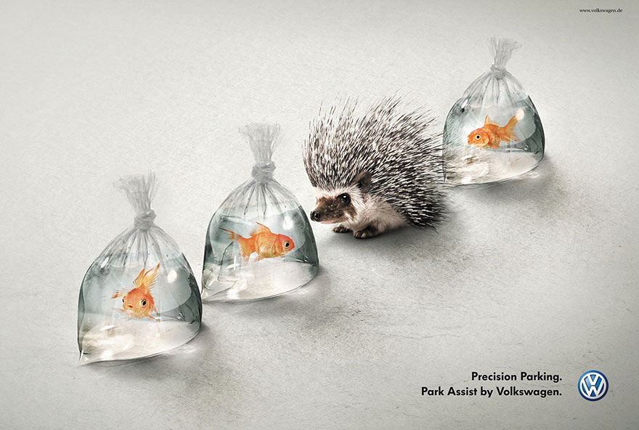

- Write at least a paragraph that describes in detail what this ad looks like.
- Get with a partner and discuss what advertising techniques the ad is using and how effective it is.

- Write at least a paragraph that describes in detail what this ad looks like.
- Get with a partner and discuss what advertising techniques the ad is using and how effective it is.

