Introduction Paragraphs ..
.
It is true that the first impression—whether it’s a first meeting with a person or the first sentence of a paper—sets the stage for a lasting impression. The introductory paragraph of any paper, long or short, should start with a sentence that peaks the interest of readers. In a typical essay, that first sentence leads into two or three other statements that provide details about the writer's subject or process. All of these sentences build up to the essay's thesis statement.
The introduction paragraph typically has:
- Attention-Getter (Lead-in)
- Set Up for the Thesis
- Thesis/Essay Map
Attention Getters & Lead-ins
To get a paper off to a great start, writers should try to have a first sentence that engages their reader. This first sentence should be broadly related to the topic of the essay.
Ways writers can begin:
Paradoxical or Intriguing Statement
Shocking Statement or Statistic
Anecdote
Statement of the Problem
Proverb, Maxim, or Strong Statement
Set Up for a Thesis
After the attention getter or lead-in, writers need to gradually narrow the broad subject towards the thesis.
Gradually narrowing can:
provide background information,
explain underlying information,
describe the complexity of the issue,
introduce various layers of the subject, and
help transition from these more broad ideas to the narrow thesis.
Thesis Statements
A thesis statement manages to encapsulate an essay's main argument in a succinct, one-sentence comment. Beginner writers often times find it useful to create an essay map thesis, where the thesis briefly lists the areas that will be discussed in the essay.
A Thesis Statement:
has a clearly stated opinion,
but does not bluntly announce the opinion ("In this essay I will..."),
is narrow enough to write a focused essay,
but is also broad enough to write at least 3 body paragraphs,
is clearly stated in specific terms,
is easily recognized as the main idea,
is forceful and direct,
is not softened with token phrases ("in my opinion" or "I think"), and
can list the 3 main points that will be made.
In the Introduction Paragraph
NEVER EVER EVER. . .
bluntly announce the essay's intent ("In this essay I will...),
make unreasonable statements,
apologize for the material that is being written ("In my humble opinion..."),
go into a detailed account of the writing,
include random information that has nothing to do with the essay,
use an encyclopedia or dictionary definition ("According to Webster's...), and
dilly-dally. Get to it. Move confidently into the essay.
Question: How is this a graphical representation of an introduction Paragraph?
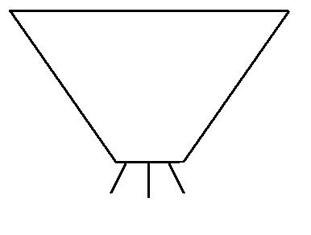
Answer: Because it starts broad, and gradually narrows towards a focused, but not overly specific thesis. The thesis is specific enough to fully explore the essay, but it's not so specific that there is nothing more to write about.
Sample Introduction Paragraph
........[Attention-Getter] After the September 11, 2001 terrorist attacks on New York's World Trade Towers and the Pentagon, the debate surrounding racial profiling in airports intensified. Many people believed that profiling was the best way to identify possible terrorists, but many others worried about violations of civil liberties. While some airports began to target passengers based solely on their Middle Eastern origins, others instituted random searches instead. [Begin setting-up the thesis] Neither of these techniques seems likely to eliminate terrorism. Now many experts in the government and in airport security are recommending the use of a national ID card or Safe Traveler Card. [Thesis] If every US citizen had such a card, airlines could screen for terrorists more effectively than they do now and avoid procedures that single out individuals solely on the basis of race.

